Erick Avalos

Professor Pottie

27 September 2019

ECE 180DA

Lab 1

1. **What you planned to do this week.**

This week, I had planned to complete all the lab requisites and requirements to succeed in the assignments. These included creating a GitHub repository, creating a SourceTree repository, installing necessary Python libraries and environments, and creating our first OpenCV program in Python.

1. **What you ended up doing this week. Explain what went wrong, what changed, and what kind of successes you may have had. Include screenshots, graphs, images and other details to best explain what happened.**

Everything that was planned for this week was completed in a timely fashion with nothing going wrong. I was able to successfully integrate the installed Python libraries into a script that detects edges of the cameras field of view. When this script was completed, I was able to commit and push the results onto my GitHub repo. The results of the script and the pushed script on GitHub is shown below:

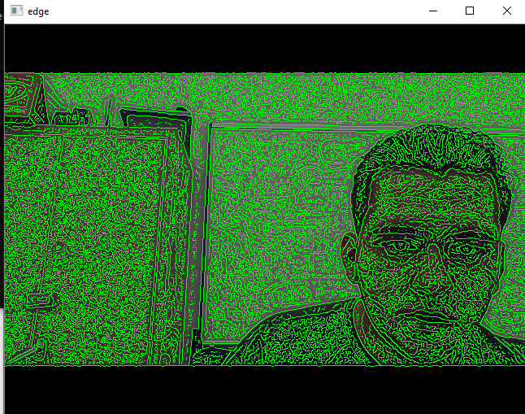 *Figure 1: Edge detection*

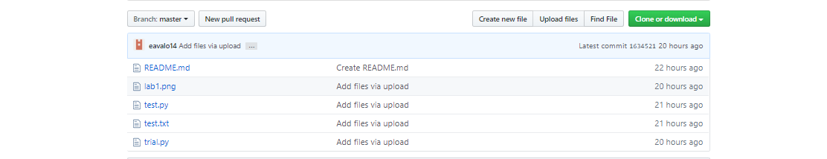

*Figure 2: GitHub Repository*

1. **What you plan to do next week.**

What I plan on doing next week are completing the desired tasks on the Raspberry Pi. These tasks include installing necessary libraries to integrate with Python, establish a virtual environment for Python integration, and finally testing all the installed software.